**Group Name: Group**

**Group Members: 3**

**Question 1 Task 1 Output:**

We developed One Music player GUI image:

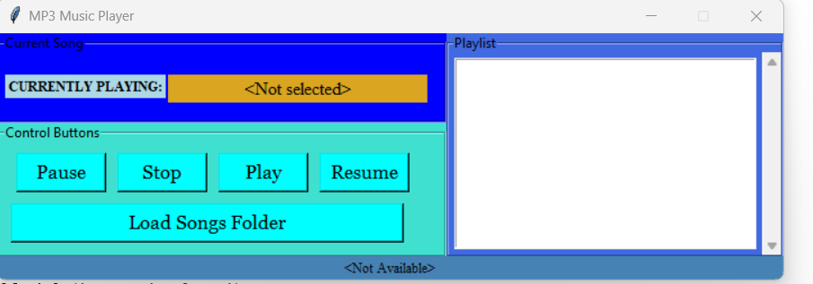

In the music player, there are 5 types of the control buttons: Pause, Stop, Play, and Resume

First, we have to load song folder one sample song is in the zip file.

Then just click the play button the song is start playing:

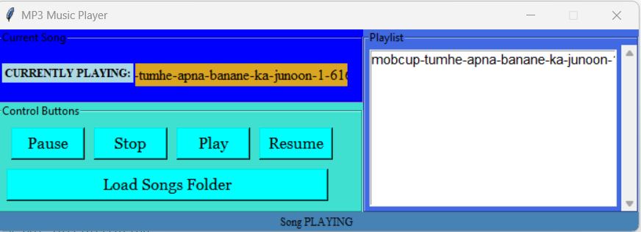

**Question 2 Task 2 Output:**

We have developed one tank based game image is at below:

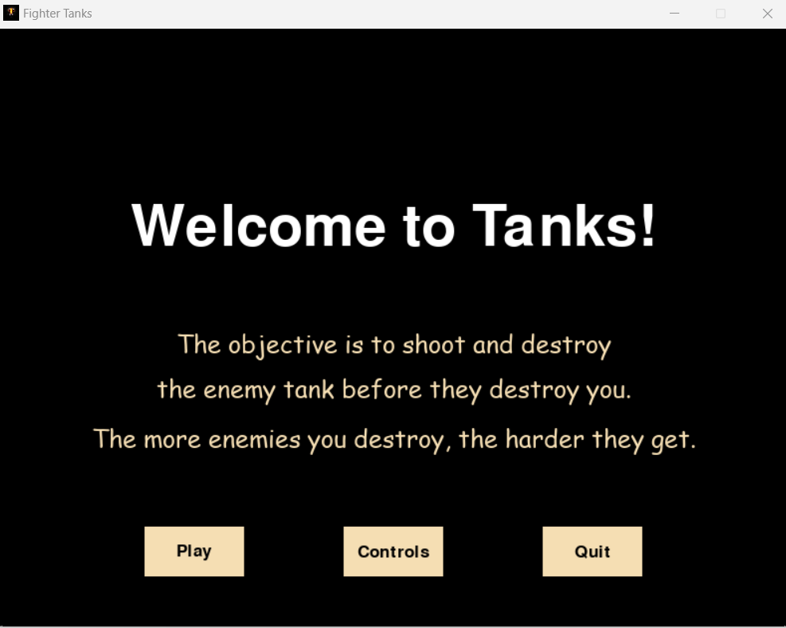

**Note: for running this code, just load the image which we attached in the zip_file**

**File_name: ic.jpeg**

First, we have to click the control button then it appears some instructions related to game:

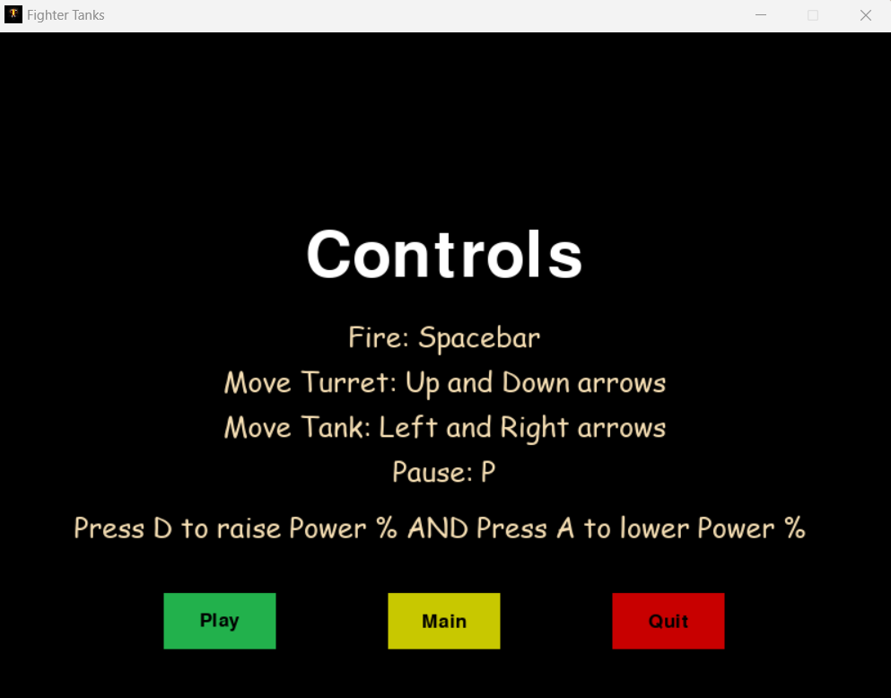

After that, just click the play button on the screen and start playing:

